Game Design Document

Fill up the following document

1. Write the title of your project.

Carrom

1. What is the goal of the game?

To make carrom using java script and firebase

1. Write a brief story of your game.

one day shubham wants to play carrom with his friends , but his friends does'nt allow him to play with them ,so shubham try to make multiplayer carrom in visual studio code with the help of his whitehat teacher and at last shubham has finished the game .

1. Which are the playing characters of this game?

* Playing characters are the ones who respond to the user based on the input from the user.
* Cars, monkeys, dinos, wizards, etc., are the playing characters in the game.

|  |  |  |
| --- | --- | --- |
| Number | Character Name | What can this character do? |
| 1 | Player 1 | Hit the striker |
| 2 | Player 2 | Hit the striker |
| 3 |  |  |
| 4 |  |  |
| 5 |  |  |
| 6 |  |  |
| 7 |  |  |
| 8 |  |  |

1. Which are the Non-Playing Characters of this game?

* Non-Playing characters are the ones that don't have an action or behavior when the user interacts with the game.
* Hurdles, stones, bananas, coins, etc., are non-playing characters in the game.

|  |  |  |
| --- | --- | --- |
| Number | Character Name | What can this character do? |
| 1 |  |  |
| 2 |  |  |
| 3 |  |  |
| 4 |  |  |
| 5 |  |  |
| 6 |  |  |
| 7 |  |  |
| 8 |  |  |

Draw your imagination of this game. What does this game look like?

* Draw the game either on your computer or on paper.
* Add images of the game scenes to show each of the playing and non-playing characters at least once.

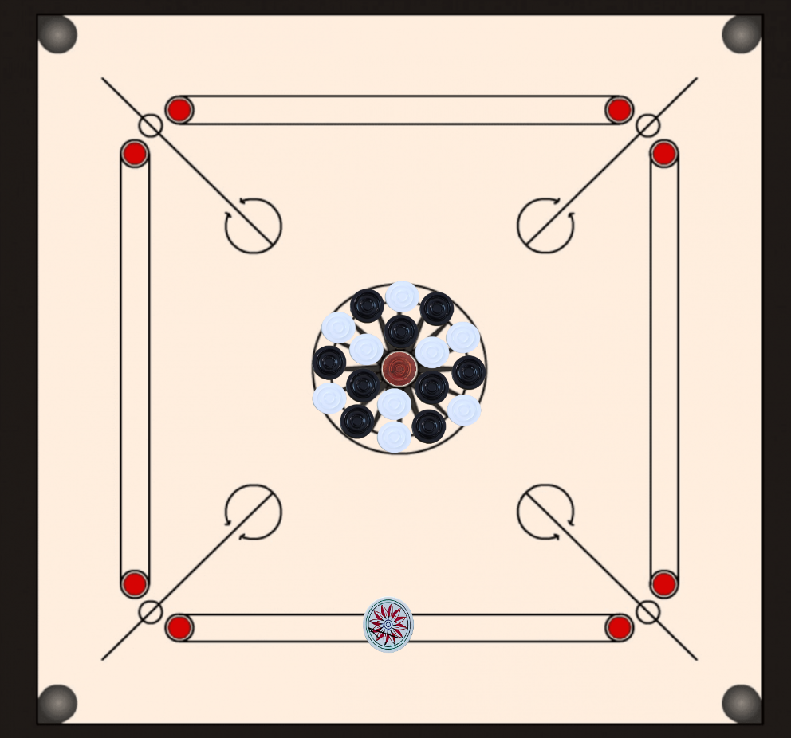

How do you plan to make your game engaging?

by making it more beautiful and attractive